**September 22th to September 26th**

Standards:

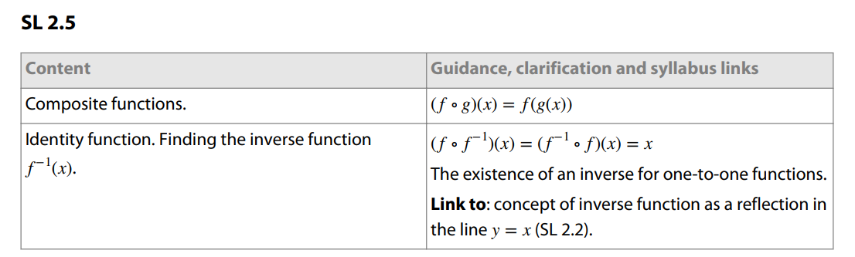

Learning Targets:

I am learning how to substitute information correctly into a composite function and solve.

I am able to identify a function and find the inverse function.

Success Criteria:

I can substitute information correctly into a composite function and solve.

I can identify a function and find the inverse function.

Chapter 2 Summary

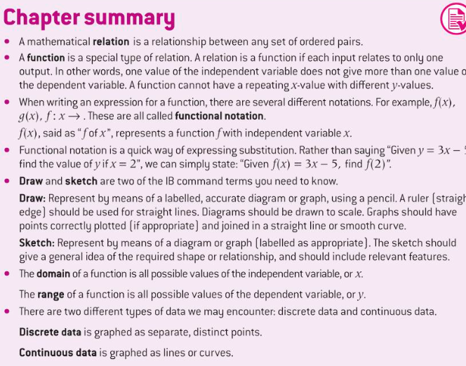

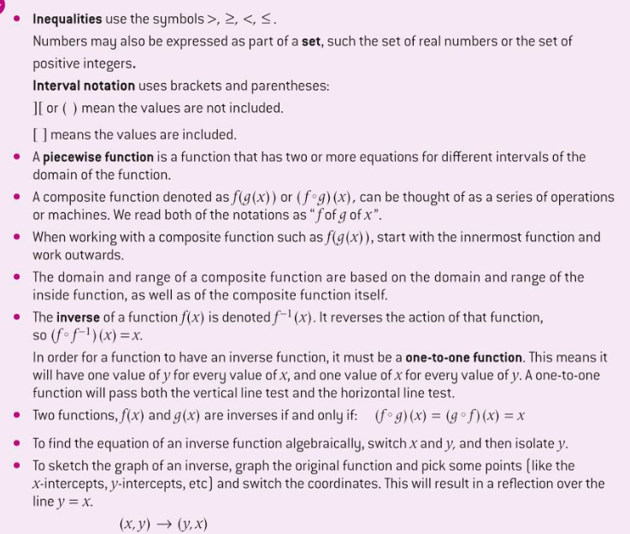

**Week at a Glance IB Year 1 Analysis and Approaches**

Monday: Open Notes Quick Quiz on Domain and Range, Composite Functions Lesson

Tuesday: Composite Functions Practice

Wednesday: Inverse Functions Notes

Thursday: Inverse Functions Practice

Friday: Inverse Functions Task